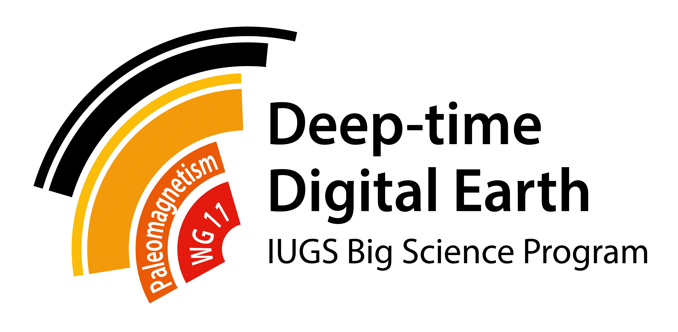

2021 AGU FALL MEETING
WG11 SESSION & WORKSHOP

Dear DDE Paleomagnetism Working Group Member,

We invite you to apply for a travel grant to cover partial costs for participation (either in-person or virtual) of the December 2021 Fall AGU Meeting, specifically events related to our project. We are planning two such events:

1. Sunday afternoon, December 12: hybrid (both in-person and virtual) workshop and information session on the Working Group. We aim to discuss not only our own missions and aims for the project, but also liaise with related DDE working groups, such as geochronology, geophysics, paleogeography, petrology & geochemistry, stratigraphy, and tectonics.

2. December 13-17: session GP014, “Progress and opportunities in deep-time paleomagnetism.” Although the Fall AGU meeting is currently intended to have a hybrid format, we are not yet certain whether our particular session will be hybrid or strictly online. It may depend on the registration information provided by our session’s participants.

Applicants are required to sign up as members of the DDE-WG11 group, on the “Join!” page of our website. In-person attendance of the workshop and meeting is optional. Funding will be preferentially granted to (i) participants from developing countries or under-represented minorities (ethnicity, gender) in the Earth Sciences; (ii) presenters in session GP014, and (iii) other indications of financial need. Students are particularly encouraged to apply, and their applications will be weighted favorably.

Abstract deadline for the Fall AGU meeting is 04 August at 23:59 EDT/03:59 +1 GMT. Late abstract submissions will not be accepted after this date.

Deadline for this grant application is 15 August 2021, at 23:59 EDT/03:59 +1 GMT.

Our Working Group’s operating budget for 2021 is limited. We thus anticipate that our funds are not sufficient to pay for any individual's entire costs of travel or registration. Therefore, these travel grants are to be considered merely as leverage funds for obtaining additional grants from a participant's home institution or other funding organization. Typical awards are expected to be about $500 each.

We look forward to your participation in our Working Group!

David Evans Johanna Salminen Shihong Zhang
DDE-WG11 Leader DDE-WG11 Co-leader DDE-WG11 Co-leader

Please fill out and email the completed form to: dde.wg11@gmail.com

WORKSHOP GRANT APPLICATION: 2021 AGU MEETING

NAME:

INSTITUTION:

COUNTRY:

GENDER (female / male / nonbinary):

TITLE(S) OF SUBMITTED ABSTRACT(S):

ESTIMATED COST OF ATTENDANCE (in US$)
Registration:
Abstract submission:
Air travel:
Lodging:
Food:

TOTAL FUNDING AVAILABLE FROM OTHER SOURCES (please provide details, including whether the funds are certain or pending application):

TOTAL REQUESTED FROM DDE PALEOMAGNETISM WORKING GROUP:
(Note that typical travel grants are likely to be about US$500.)

PREVIOUS DDE-WG11 TRAVEL GRANT SUPPORT (year and amount):

ANY OTHER INFORMATION RELEVANT TO CONSIDERATION OF THIS APPLICATION (you may append an additional page if necessary):

Save and email the completed form as an attachment to: dde.wg11@gmail.com

